
Organized by tSt GROUP
Official website: http://tstgroup.com.tw/
Official line: https://line.me/R/ti/p/%40yqk4340c
Email: tstgroup.service@gmail.com
Competition Date: May 9, 2021
Venue: New Taipei City Luzhou Breeze Park Google Map
Registration time: present~ 2021/3/25.
Registration fee (NT):
2020 Breeze athlete invite a new friend to join the race(not including relay), both of you get 10% off discount before 2020/12/31. (The system will check passport number and show discount before payment.)
Race Categories | Early Bird | Price
 | 2021.11.1 ~ 2021.01.31 | 2021.02.01 ~ 2020.3.25
113km Triathlon | NT. 5700 | NT. 6600
113km Triathlon Relay | NT. 7700 | NT. 8600
Standard Triathlon | NT. 2600 | NT. 3100
Standard Triathlon Relay | NT. 4200 | NT. 5100
Sprint Triathlon | NT. 2000 | NT. 2600
Youth Triathlon | NT. 1700 | NT. 2000
Beauty Triathlon | NT. 1700 | NT. 2000
Duathlon | NT. 2000 | NT. 2600

113 KM Triathlon . Relay | swim 1.9km - bike 90km – run 21km
51.5 KM Triathlon . Relay | swim 1.5km - bike 40km – run 10km
25.75 KM Sprint Triathlon | swim 750m - bike 20km – run 5km
12.9 KM Beauty Triathlon | swim 400m - bike 10km – run 2.5km
12.9 KM Youth Triathlon | swim 400m - bike 10km – run 2.5km
50 KM Duathlon | run 5km - bike 40km – run 5km

Athlete Package pick-up：
 | Time | Venue
Pick up on 2021/05/08 (Sat.) | 13：00 － 17：00 | Luzhou Breeze Park
Home deliver | One week before race day
1. When checking-in please present your personal ID or documents (passport, driver’s license, etc).
2. We accept agent to do the registration. Please bring the copy of participant ID card.
Shipping
1-2 person | 3-10 person | 11-30 person
NT. 100 | NT. 200 | NT.400
Bike Check in：get time chip after bike check-in.
Date | time
2021.05.08 (Sat.) | 13：00 － 17：00
2021.05.09 (Sun.) | 05：00 － 05：40

Schedule
2021/05/08
13：00 － 17 : 00 | 1. Athlete Check-In 2. TA Open (Bike Check-in)
15 : 30 － 17 : 00 | Race Briefing (Chinese)
2021/05/09
5：00 － 5：40 | TA Open (Bike Check-in)
5：30 － 5：40 | Swim trial
6：00 | 113 Triathlon Start ( 5:40 athletes assemble )
6：10 | Duathlon Start ( 6:00 athletes assemble )
6：30 | Standard Triathlon Start ( 6:10 athletes assemble )
7：00 | Sprint Triathlon Start ( 6:40 athletes assemble )
7：20 | Youth and Beauty Triathlon Start ( 7:00 athletes assemble )
10：00 | Ceremony (estimated)
11：30 | TA Open. Bike Check-out (estimated)
Athletes who don’t finish the single event can still continue the next one with time chip after registering at the tent in the transfer area.

Route
113 KM Triathlon . Relay | swim 1 lap - bike 6 laps – run 2 laps
51.5 KM Triathlon . Relay | swim 1 lap - bike 4 laps – run 1 lap
25.75 KM Sprint Triathlon | swim 1 lap - bike 2 laps – run 1 lap
12.9 KM Beauty Triathlon | swim 1 lap - bike 1 lap – run 1 lap
12.9 KM Youth Triathlon | swim 1 lap - bike 1 lap – run 1 lap
50 KM Duathlon | run 1 lap - bike 4 laps – run 1 lap
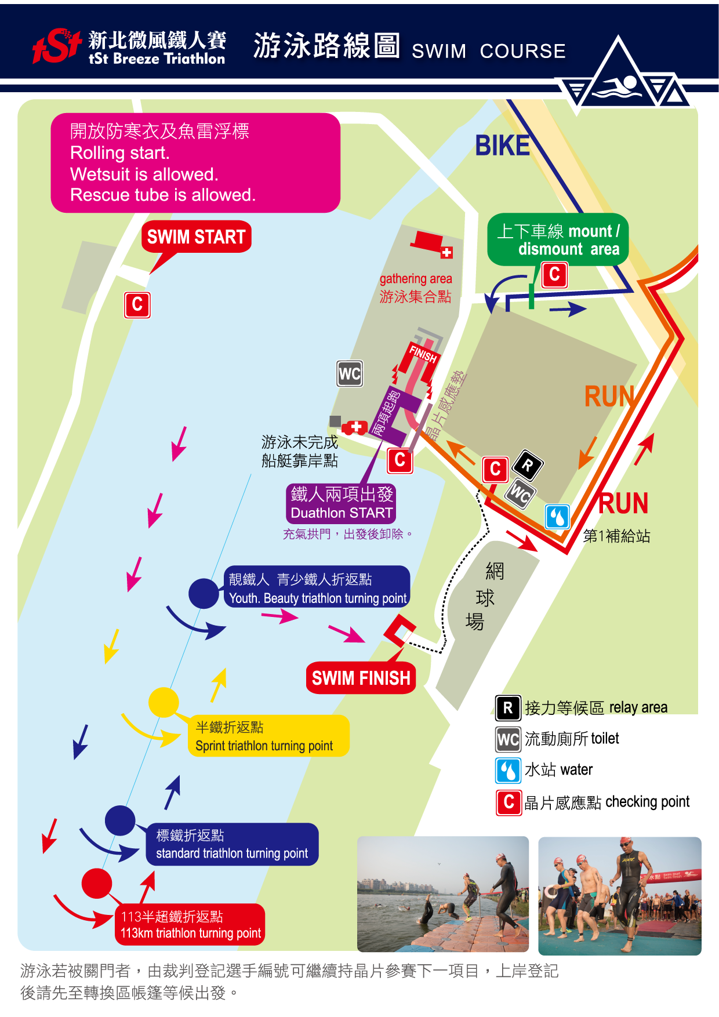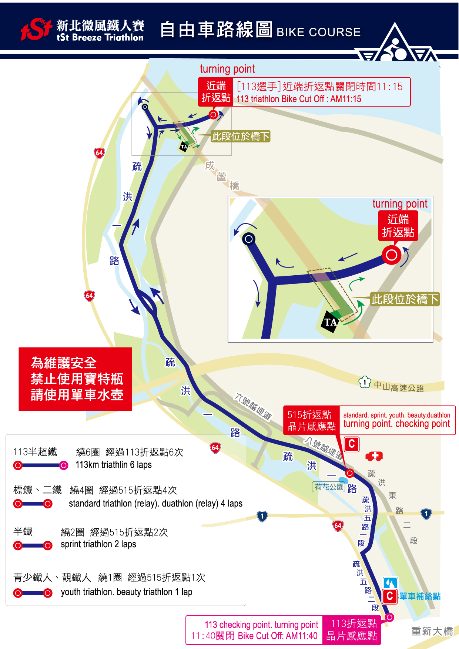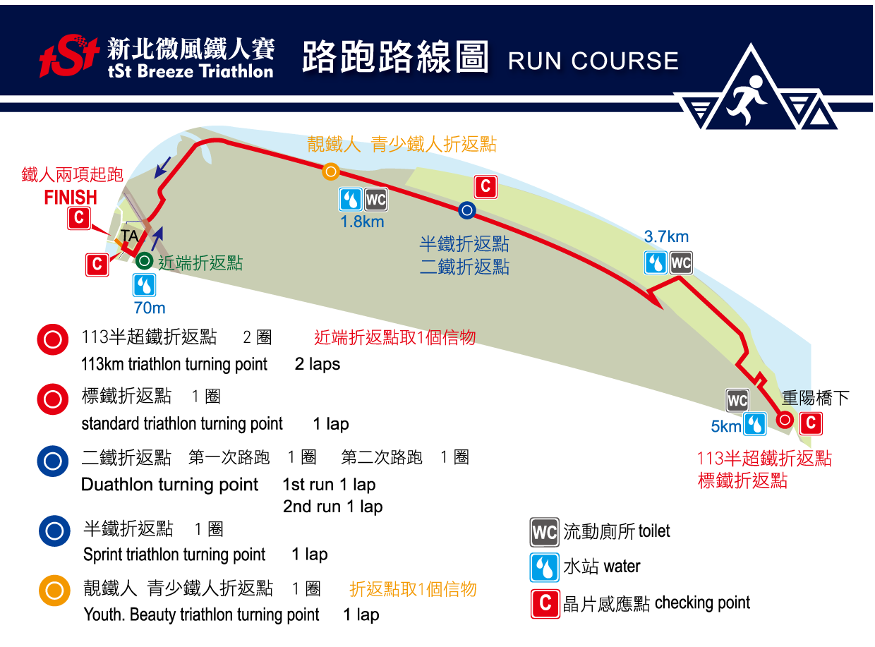

Service and souvenirs：more information will be published on official website
 | accident insurance | Time chip | T shirt | Swimming cap | (finisher)  medal | Certificate | food | Finisher gift
113km | ×1 | ×1 | ×1 | ×1 | ×1 | ×1 | ×1 | ×1
113km relay | ×3 | ×1 | ×3 | ×1 | ×3 | ×3 | ×3 | ×3
Standard | ×1 | ×1 | ×1 | ×1 | ×1 | ×1 | ×1 | ×1
Standard relay | ×3 | ×1 | ×3 | ×1 | ×3 | ×3 | ×3 | ×3
Sprint | ×1 | ×1 | ×1 | ×1 | ×1 | ×1 | ×1 | ×1
Youth triathlon | ×1 | ×1 | ×1 | ×1 | ×1 | ×1 | ×1 | ×1
Beauty triathlon | ×1 | ×1 | ×1 | ×1 | ×1 | ×1 | ×1 | ×1
Duathlon | ×1 | ×1 | ×1 |  | ×1 | ×1 | ×1 | ×1
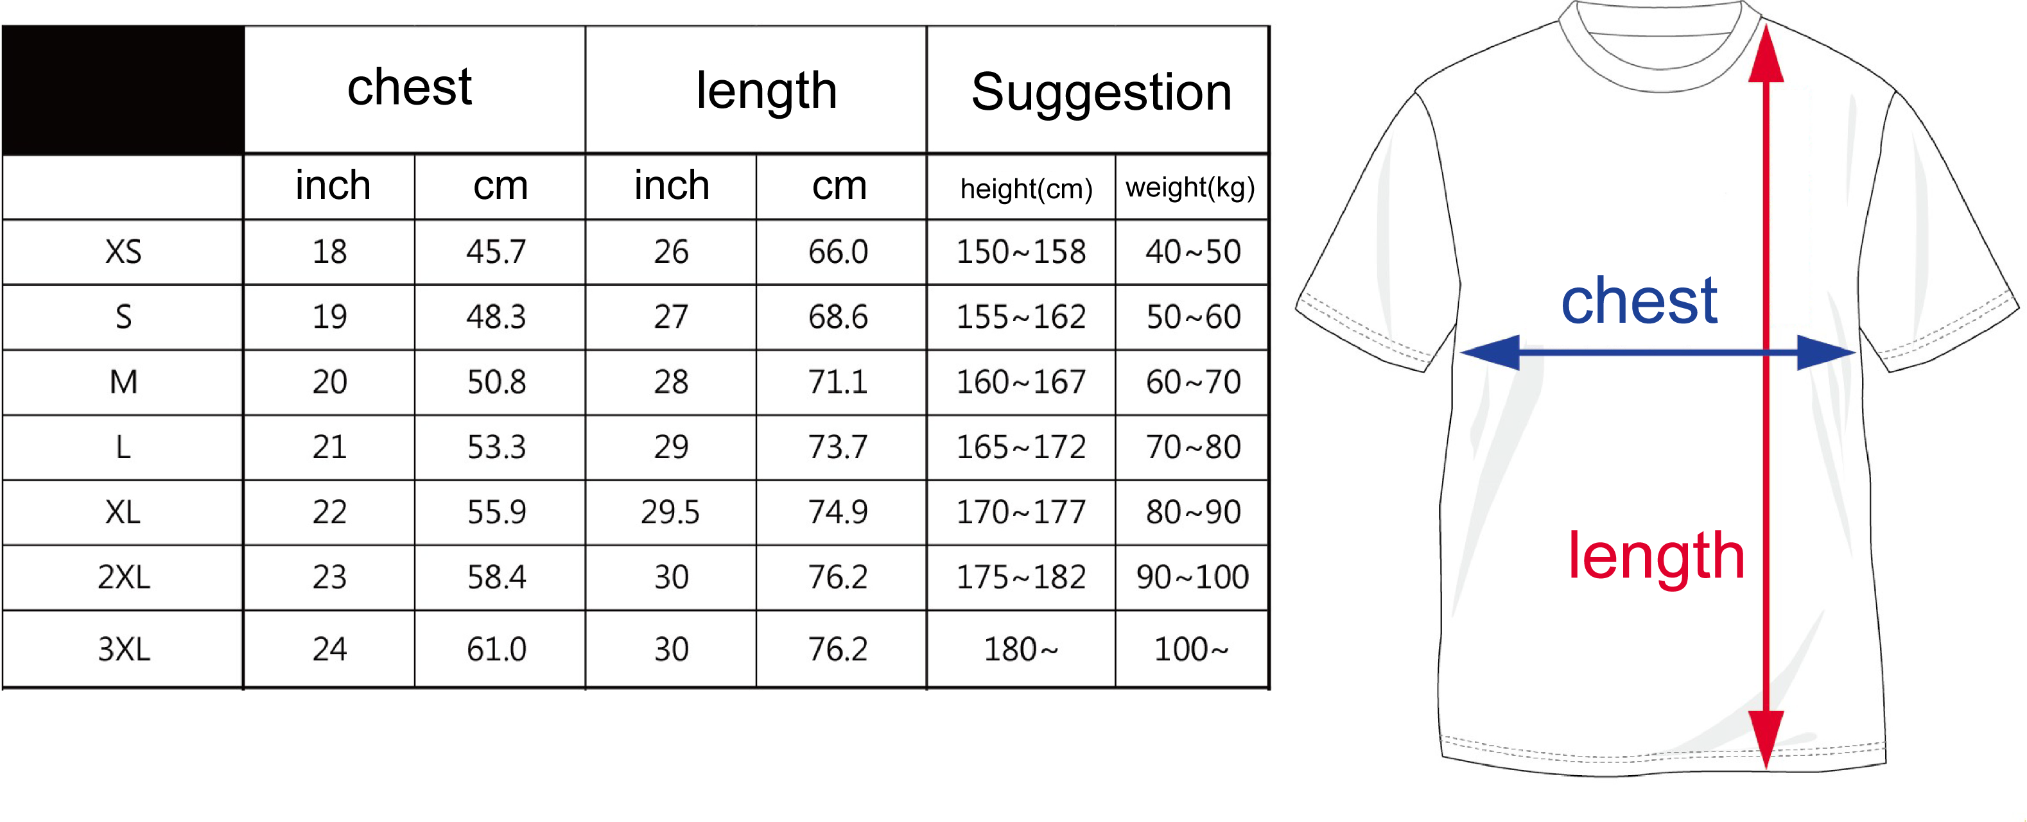

 | 113km |  | standard |  | sprint |  | duathlon |  | note
Age group | male | female | male | female | male | female | male | female
Age group | M20 | M20 | M20 | M20 | M20 | M20 | M20 | M20 | Under 25 (≧1997)
Age group | M25 | M25 | M25 | M25 | M25 | M25 | M25 | M25 | 25～29 (1992～1996)
Age group | M30 | M30 | M30 | M30 | M30 | M30 | M30 | M30 | 30～34 (1987～1991)
Age group | M35 | M35 | M35 | M35 | M35 | M35 | M35 | M35 | 35～39 (1982～1986)
Age group | M40 | M40 | M40 | M40 | M40 | M40 | M40 | M40 | 40～44 (1977～1981)
Age group | M45 | M45 | M45 | M45 | M45 | M45 | M45 | M45 | 45～49 (1972～1976)
Age group | M50 | M50 | M50 | M50 | M50 | M50 | M50 | M50 | 50～54 (1967～1971)
Age group | M55 | M55 | M55 | M55 | M55 | M55 | M55 | M55 | 55～59 (1962～1966)
Age group | M60 | M60 | M60 | M60 | M60 | M60 | M60 | M60 | 60～64 (1957～1961)
Age group | M65 | M65 | M65 | M65 | M65 | M65 | M65 | M65 | 65～69 (1952～1956)
Age group | M70 | M70 | M70 | M70 | M70 | M70 | M70 | M70 | Above 70 (≦1951)
Relay | 113 relay |  | standard relay

Youth triathlon | junior boy | Boy under 15 (≧2007)
Youth triathlon | Junior girl | Girl under 15 (≧2007)
Youth triathlon | Youth boy | Boy 15～18 (2003～2006)
Youth triathlon | Youth girl | Girl 15～18 (2003～2006)
Beauty triathlon |  | Female only

Prize
- The overall Ranking (Crystal Trophy)
Those who have received the overall ranking prizes will not be awarded according to group ranking.
113km triathlon | Male overall Ranking  Female overall Ranking | 1st-6th  1st-6th
51.5 standard triathlon | Male overall Ranking  Female overall Ranking | 1st-6th  1st-6th
- The Group Ranking (Crystal Trophy)
The group taking the number of awards (not including above groups)
Participants | 1-5 | 6-10 | 11-15 | 16-20 | 21-25 | 26-30 | More than 50
Awards | 1 | 2 | 3 | 4 | 5 | 6 | 7

item | 113km |  | Standard |  | Sprint |  | Duathlon |  | Youth | Beauty
group | male | female | male | female | male | female | male | female
group | M20 | M20 | M20 | M20 | M20 | M20 | M20 | M20 | Junior boy | Beauty group
group | M25 | M25 | M25 | M25 | M25 | M25 | M25 | M25 | Junior girl
group | M30 | M30 | M30 | M30 | M30 | M30 | M30 | M30 | Youth boy
group | M35 | M35 | M35 | M35 | M35 | M35 | M35 | M35 | Youth girl
group | M40 | M40 | M40 | M40 | M40 | M40 | M40 | M40
group | M45 | M45 | M45 | M45 | M45 | M45 | M45 | M45
group | M50 | M50 | M50 | M50 | M50 | M50 | M50 | M50
group | M55 | M55 | M55 | M55 | M55 | M55 | M55 | M55
group | M60 | M60 | M60 | M60 | M60 | M60 | M60 | M60
group | M65 | M65 | M65 | M65 | M65 | M65 | M65 | M65
group | M70 | M70 | M70 | M70 | M70 | M70 | M70 | M70
group | 113km relay |  | Standard relay

Attention
- We provide athletes the accident insurance for the activity. The participants can buy their own.
- If there is a typhoon or any other natural disaster on the race day, we have the right to call off or delay the race, or change the racecourse.
- The regulation would be modified if necessary. Please pay attention to the official information.
- After registration closed, the athlete list will be published on official website.
- Time-chip will be given after bike-check-in at TA and the athlete should return it when bike-check-out. The participant must pay NT1000 if it is lost.
- Rolling start. Wetsuit is allowed. Rescue tube is allowed.
- More information will be published on official website. (http://tstgroup.com.tw/)

